Castle Adventure.

Game pitch

This game is set in a medieval Japanese castle. It 2D side scrolling plat former game. Players will have to make their way to the heart of the castle to defeat the evil dragon ninja zombie. Players will be equipped with their trusty sword. The castle will be filled with ninja zombies that threaten the land. Player will have to make tight jump to reach platforms. Player will have a life bar.

Back story.

A great worrier of the past took of his sword and went to slay the might dragon that terrorized the land. His victory was celebrated throughout the land. Years pasted with peace is all the locals knew. The story became nothing more than just a myth. Until one day. An evil witch cast out by the locals seeked for her revenge. She entered the just castle on the mountain where the dragon lived. She found the remains. Using a her magic he raised the dragon back to life. Well undead really. The dragon started his reign of terror once again. Now it’s up to you to the great of the ninja worriers to slay the might dragon and restore peace to the land.

Game play

This game is set in a medieval Japanese castle. It 2D side scrolling plat former game. They will have to defeat enemies as they move across platforms. Find health potions as they go. Till they reach and defeat the boss.

Basic controls

Players can move left, right, jump and swing their sword.

Scene layout.

Players will be set in a medieval Japanese style castle. Their will be platforms to run and jump on. Holes with deadly traps spikes and bottomless pits.

**Inspiration and example of the game.**

**Castlevania. Is an example of the game. Castlevania as always been one of the favourite games to play.**

**I can say no for having the chance to make my own side scrolling adventure.**

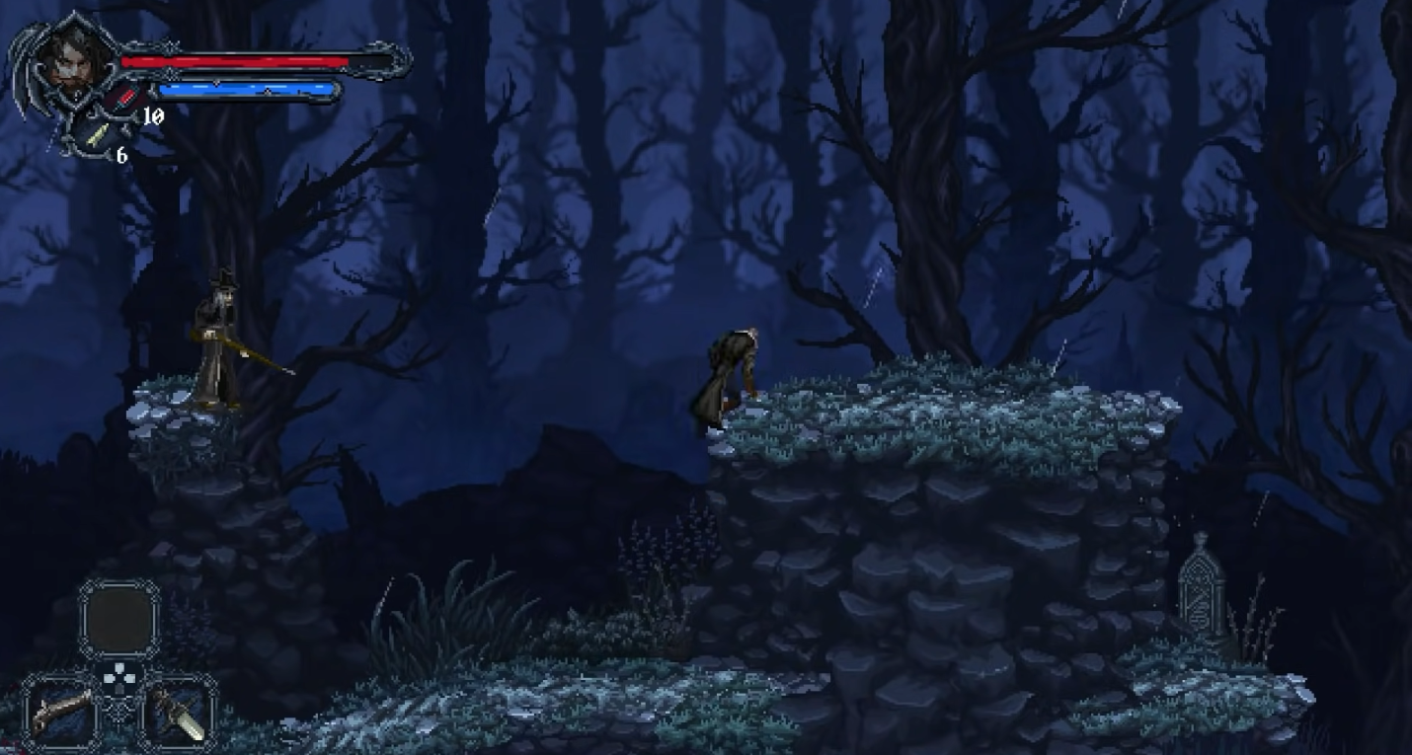

**Why should players choose to play this game.**

Which play have ever had the pleasure of kill a ninja zombie. No side scroll I have ever seen has been set with a combination of medieval and Japanese styles together.